
SVKM’s INSTITUTE OF TECHNOLOGY, DHULE
Department of Information Technology
Academic Year 2025-26

Experiment 8

Name: Bhupesh Anil Suryawanshi
Roll No.: 63
Batch: B3

Aim: To design and implement a Fuzzy Inference System (FIS) using the Mamdani fuzzy inference mechanism
.

Theory:
A Fuzzy Inference System (FIS) is the decision-making core of a fuzzy logic system. It applies reasoning on fuzzy rules to generate outputs based on given inputs. FIS uses IF–THEN rules with logical operators such as AND / OR to map input variables to output variables.

Key Features of FIS:
- The output of FIS is always fuzzy, regardless of whether the input is crisp or fuzzy.
- When FIS is used for control, fuzzy output is necessary.
- A defuzzification stage is used to transform fuzzy outputs into crisp values for real-world applications.

Functional Components of FIS:
- Rule Base – Contains fuzzy IF–THEN rules.
- Database – Defines membership functions of fuzzy sets.
- Decision Unit – Applies fuzzy reasoning to the rules.
- Fuzzification Unit – Converts crisp inputs into fuzzy values.
- Defuzzification Unit – Converts fuzzy output back into a crisp value.

Working of FIS:
The step-by-step process:
- Fuzzification – Crisp inputs are converted into fuzzy values using MFs.
- Knowledge Base Formation – Rule base and database together form the knowledge base.
- Rule Evaluation – Fuzzy inputs are combined according to fuzzy rules to calculate firing strength.
- Implication – Output MFs are modified according to the firing strength of each rule.
- Aggregation – All rule outputs are combined to form a single fuzzy output.
- Defuzzification – The aggregated fuzzy output is transformed into a crisp value.

Methods of FIS:
- Mamdani Fuzzy Inference System (MFIS)
  - Proposed by Ebrahim Mamdani (1975) for controlling a steam engine and boiler.
  - Uses fuzzy sets for both input and output.
  - Best suited for systems that require human-like reasoning.
- Sugeno (Takagi-Sugeno) Model
  - Uses linear equations or constants in consequents.
  - More computationally efficient.

Steps in Mamdani FIS Computation:
- Define a set of fuzzy rules.
- Fuzzify the crisp input values.
- Evaluate the rules using fuzzy operators.
- Modify the output MF (implication).
- Aggregate results of all rules.
- Defuzzify the final output.

Block Diagram of Fuzzy Inference System :

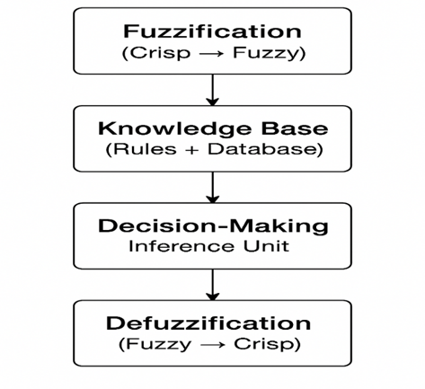

Conclusion :

The Mamdani Fuzzy Inference System (FIS) enables human-like decision-making by mapping crisp inputs to fuzzy outputs through defined rules and membership functions.
It processes fuzzification, rule evaluation, implication, aggregation, and defuzzification to generate accurate outputs.
Thus, Mamdani FIS is highly effective for control systems requiring interpretability and reasoning similar to human expertise.

Block diagram of Mamdani Fuzzy Interface System:

